**VIETNAM NATIONAL UNIVERSITY, HO CHI MINH CITY**

**UNIVERSITY OF TECHNOLOGY**

**FACULTY OF COMPUTER SCIENCE AND ENGINEERING**

🙞∙∙∙☼∙∙∙🙜



**SOFTWARE ENGINEERING ASSIGNMENT**

**PROJECT: UWC 2.0 (TASK 1)**

**CC02 --- GROUP HÍ HÍ HÌ HÌ --- SEM 221**

**SUBMIT: 21/09/2022**

**INSTRUCTOR: PROF. ĐỨC ANH**

|  |  |
| --- | --- |
| **Students’ name** | **Student’s ID** |
| Nguyễn Viết Hòa | 2052486 |
| Trần Gia Linh | 2053182 |
| Nguyễn Mỹ Khanh | 2052525 |
| Trần Ngọc Oanh | 2053312 |
| Phạm Thị Thái Minh | 2052174 |

**Ho Chi Minh City – 2022**

**Contents**

TASK 1: REQUIREMENT ELICITATION 3

1 CONTEXT OF PROJECT 3

1.1 STAKEHOLDERS: 3

1.1.1 External: The parties or groups that are not a part of the organization, but gets affected by its activities 3

1.1.2 Internal: The individual and parties that are the part of the organization 3

1.2 CURRENT PROBLEMS OF URBAN WASTE MANAGEMENT: (POSSIBILITIES) 3

1.2.1 Waste management 3

1.2.2 Organization: 3

1.3 CURRENT NEED OF STAKEHOLDERS: 4

1.4 BENEFITS 4

2 REQUIREMENTS INDENTIFY AND USE-CASE FOR WHOLE SYSTEM 5

2.1 Identify Requirements 5

2.1.1 Function requirements 5

2.1.2 Non-function requirements: 6

2.2 Use-case Diagram: 7

3 TASK ASSIGNMENT MODULE USE-CASE DIAGRAM AND TABLE 8

3.1 Use-case diagram 8

3.2 Use-case Table 9

# TASK 1: REQUIREMENT ELICITATION

# CONTEXT OF PROJECT

## STAKEHOLDERS:

Internal stakeholders are people whose interest in a company comes through a direct relationship, such as employment, ownership, or investment. External stakeholders are those who do not directly work with a company but are affected somehow by the actions and outcomes of the business.

### External: The parties or groups that are not a part of the organization, but gets affected by its activities

1. Government
2. Citizen of nearby area
3. Private Sweeper
4. Citizen paying for service
5. Service provider Y

### Internal: The individual and parties that are the part of the organization

1. Back officers
2. Collectors
3. Janitors
4. Organization X

## CURRENT PROBLEMS OF URBAN WASTE MANAGEMENT: (POSSIBILITIES)

### Waste management

Urban waste collected at temporary disposal are not separated between organic and non-organic waste => No training about waste management

Temporary dumps usually are not well-managed => Create population and health risk for local communities.

Private Sweepers usually use old technology to collect and dispose waste, they do not obtain modern and efficient technology to properly dispose waste.

### Organization:

**Back officer:**

Lack information about type of vehicles and MCPS => Do not know how to assign task for janitors and collectors.

**Collectors and Janitors:**

Need to learn to use multiple different platforms to perform their task correctly (Calendar to see work shifts, Map to see the proper route, etc, …) => More time training. Unable to get access to emergencies immediately, have to make a call and remember who are their supervisors.

Unable to focus on their specialization, have to be cautious for everything (is MCP full, which route is the most efficient, …)

Unable to get access to the necessary information and have to make requests for everything.

## CURRENT NEED OF STAKEHOLDERS:

**Citizen:** Need better waste management. Get informed about waste collection calendar to properly classify trash and dumps. Need healthier environment where trash is not around.

**Government:** Need better waste management. Trash dumps are well-managed => Waste do not contaminate water and land source. More modern and green technology to process waste.

**Back officer:** Information about janitors and collectors, their work calendar. Have an overview of vehicles and their technical details (weight, capacity, fuel consumptions, etc)

Have an overview of all MCPs and information about their capacity. Information should be updated from MCPs every 15 minutes with the availability of at least 95% of their operating time

Map of area (include traffic information, route, distance and fuel consumption) to properly locate MVP and send collectors, janitors.

Ability to contact collectors and janitors for emergency.

**Collectors and Janitors:** Information about their work shifts (include time, location and MVP they are assigned to). Have a detail view of their task on a daily and weekly basic. All important information should be displayed in one view (without scrolling down).

Be able to communicate with collectors, other janitors and back officers. The messages should be communicated in a real-time manner with delay less than 1 second

Collectors: Route to get to their destinations. Information about their vehicles (max capacity, fuel consumption, …). Type of their MCPs and contact info of janitors who are responsible for their MCPS. Notified if the MVPS is fully loaded

Janitors: Map of their assigned area. Notified if the MVPS is fully loaded. Route to get to their MVPS and information of family (waste type, …) they are going to collect.

## BENEFITS

**Citizen:** Better waste management. Trash is collected on same schedule and location => Easier to keep track.

**Government:** Better waste management. Trash dumps are well-managed. Better environment where trash is handled with utmost care.

**Back officer:** Can easily keep track of collectors and janitors work calendars. Can easily obtain information about different kinds of vehicle, route and MCPS => Easier to assign work calendars and proper vehicles for collectors and janitors.

Can immediately contact with collectors and janitors => Keep them informed about emergency or sudden change of route because of traffic problems.

**Collectors and Janitors:** Can keep track of their work shift easily, can focus on their specializations without caring too much about external information. Can get access to their work information directly => Need less training on how to use the platform => Less thing to remember and work on.

Be able to communicate with collectors, other janitors and back officers to inform about emergencies and get notified about sudden change of plans immediately.

# REQUIREMENTS INDENTIFY AND USE-CASE FOR WHOLE SYSTEM

## Identify Requirements

“In reality, the distinction between different types of requirements is not as clearcut as these simple definitions suggest. A user requirement concerned with security, such as a statement limiting access to authorized users, may appear to be a nonfunctional requirement.”

(Software Engineering _ Ian Sommerville)

As the book has stated, there is no clear distinction between function and non-function requirement hence our below specifications are based mainly on our intuition, knowledge and experience.

### Function requirements

As a back officer, a collector and a janitor, I want a **Chat box** so that I can contact to the others.

As a back officers, I want a **Calendar** so that I can assign the tasks for collectors and janitors, the route for collectors, the MCPs for the collectors and the janitors.

As a collector and a janitor, I want a **Calendar** so that I can see my tasks in daily and week basic and check in/ check out my work in any time.

As a back officer, I want a **Vehicle management** so that I can know the details of the vehicles (weight, capacity, fuel consumptions, in-use, etc) and assign vehicle for the collectors.

As a back officer, a collector and a janitor, I want a MCPs management system with a map so that I can design the route, keep up with the MCPs state and be notified if the MCPs are fully loaded.

### Non-function requirements:

As a back officer, I want **efficiency** so that the system can handle real-time data from at least 1000 MCPs at the moment and 10.000 MCPs in five years.

The system **interfaces** should be in Vietnamese, with a button to switch to English.

As a user, I want **high-speed** so that the messages can be communicated in a real-time manner with delay less than 1 second.

The information should be updated from MCPs every 15 minutes with the **availability of at least 95%** of their operating time.

## Use-case Diagram:

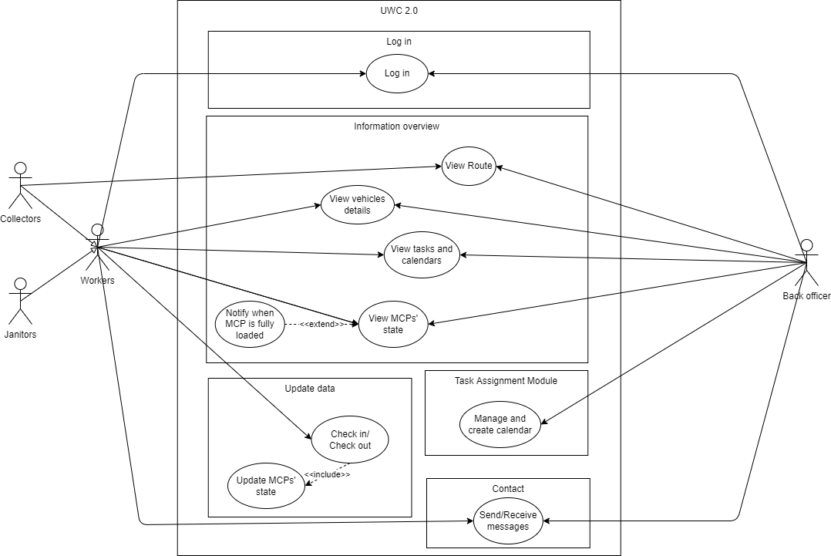As you can see in the use-case diagram, we divide our program into **5** main parts:

Figure 2.1: Use-case Diagram for the whole system

1. **Log in:** In this part, we will allow users (Workers and Back Officer) to log in their accounts to verify their identities. There are restricted parts for different users, therefore, this log in part will help improving security and help us to protect private personal information.
2. **Information Overview:** This part will allow users to view their own data included their routes (collector-only), information about the vehicles they are going to use, their tasks, calendars and state of their assigned MCP. Back officer can also interact with this part in order to get access to all their supervisees’ information to assign the job more efficiently. However, this part will contain no update/modify functions. This part will only be used to view data to allow for simplicity.
3. **Update data:** In this part, workers will update information about their shifts/task by using check in/ check out functions, to allow information about MCP to be constantly updated, when a worker check out, they will need to update the state of their current MCP.
4. **Task Assignment Module:** This part will help the Back Officers to assign and then update the necessary information about tasks/calendars, … for the workers. This part will be analyzed further below in Part 3.
5. **Contact:** Last but not least, this part will help both Workers and Back Officers to communicate with each other in case of emergency. This attribute will help to enhance communication and solidarity among peers in work.

# TASK ASSIGNMENT MODULE USE-CASE DIAGRAM AND TABLE

## Use-case diagram

Figure 3.1: Use-case diagram of Task Assignment Module

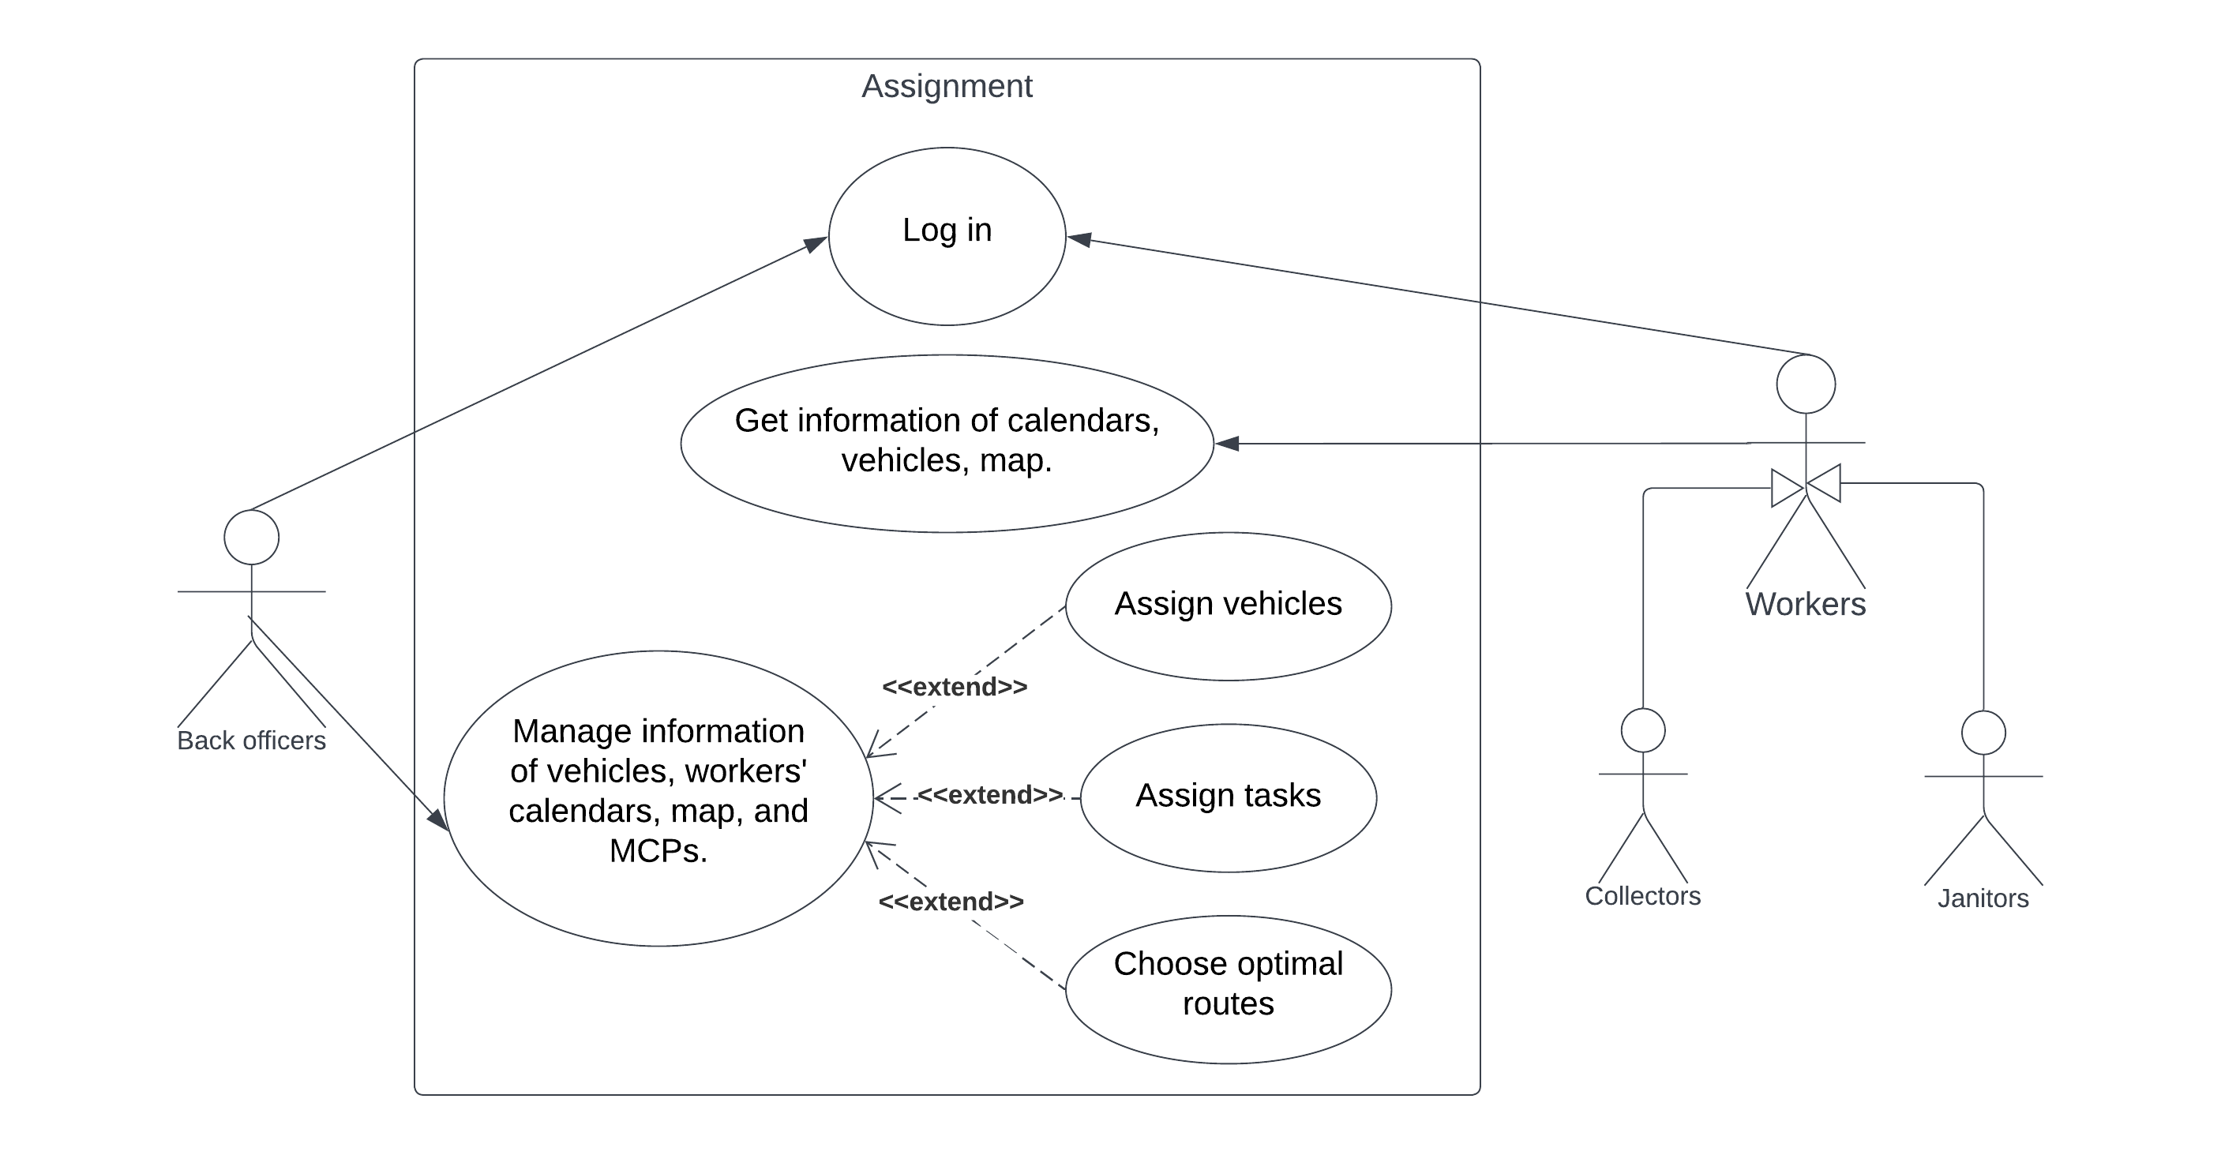

**<<include>>**

## Use-case Table

|  |  |
| --- | --- |
| Use-case name | Manage and Create Calendar |
| Actors | Back Officer |
| Trigger Condition | Back officer clicks "Manage information" in the main menu. |
| Description | Back officers get and edit information of vehicles, workers' calendars, and maps. |
| Pre-Conditions | Internet access. |
| Post-Conditions | System has detail information. |
| Main Flow | 1. System shows 3 buttons - Vehicles, Calendar, and Map. 2. Back officer chooses one button. 3. System shows detailed information about the chosen aspect. |
| Exception | If internet connection is corrupted, system will show "There is no connection". |
| Alternative flow | At step 1, if Internet access is unstable, a notification will display and request users to refresh the page in order to re-access. |

|  |  |
| --- | --- |
| Use-case name | Assign vehicles |
| Actors | Back Officers |
| Trigger Condition | Back officer chooses "Vehicles" button in Manage information menu. |
| Description | Back Officers assign vehicles to workers. |
| Pre-Conditions | Database is available and Internet access. |
| Post-Conditions | Unused vehicles are assigned to free workers. |
| Main Flow | 1. Back officer clicks the "Available" button. 2. System shows a list of unused vehicles with "Add person" button next to. 3. Back officer clicks "Add person" button of a vehicle. 4. System shows a list of workers who can use the vehicle. 5. Back officer chooses one worker and clicks the "Save button". 6. System saves the new information. |
| Exception | At step 2, if there is no available vehicle, the system will alert back officer and ask back officer to return to the previous menu. |
| Alternative flow | At every step from step1 to step5, there may have Internet corruption. If that situation occurs, a notification will display and request users to refresh the page in order to re-access. |

|  |  |
| --- | --- |
| Use-case name | Assign tasks |
| Actors | Back Officers |
| Trigger Condition | Back officer chooses "Calendar" button in Manage information menu. |
| Description | Back Officers assign tasks for workers. |
| Pre-Conditions | Database is available and Internet access. |
| Post-Conditions | Tasks are assigned to free workers. |
| Main Flow | 1. Back officer clicks the "Available" button. 2. System shows available calendars. 3. Back officer chooses one collector/janitor's calendar. 4. System shows details of the chosen calendar. 5. Back officer adds a new task to the available time and clicks the "Save button". 6. System saves the new information. |
| Exception | At step 2, if there is no available calendar, the system will alert back officer and ask back officer to return to the previous menu. |
| Alternative flow | At every step from step1 to step7, there may have Internet corruption. If that situation occurs, a notification will display and request users to refresh the page in order to re-access. |

|  |  |
| --- | --- |
| Use-case name | Choose optimal routes |
| Actors | Back Officers |
| Trigger Condition | Back officer chooses "Map" button in Manage information menu. |
| Description | Back Officers decide appropriate routes for collectors. |
| Pre-Conditions | Database is available and Internet access. |
| Post-Conditions | The most optimal route is chosen |
| Main Flow | 1. Back officer sees the map and chooses one collector and destination. 2. System shows the top 3 shortest routes from the collector's position to the destination. 3. Back officer decides the optimal one and clicks "Save button". 4. The system saves new information. |
| Exception |  |
| Alternative flow | At every step from step1 to step5, there may have Internet corruption. If that situation occurs, a notification will display and request users to refresh the page in order to re-access. |

_________________________________